Emerging Software Engineering Principles

Project Sprint 3 Submission

John Foster, Clifton Malecki, Vladmir Maximov, Koko Afantchao

GitHub URL: <https://github.com/jtfoster2/Outdora>

Story Point Forecast: Sprint 1 was approximated to be 16 points of work across the team, and we assumed 24 points for Sprint 2, but actually completed 68 points worth of work. We’d assume about 40 points, but with the half sprint, we’re assuming 20 points of work for Sprint 3.

GitHub Projects Board URL: <https://github.com/users/jtfoster2/projects/1/views/1>

Tasking Proof: Stories are split into tasks using checkboxes in the issue description:

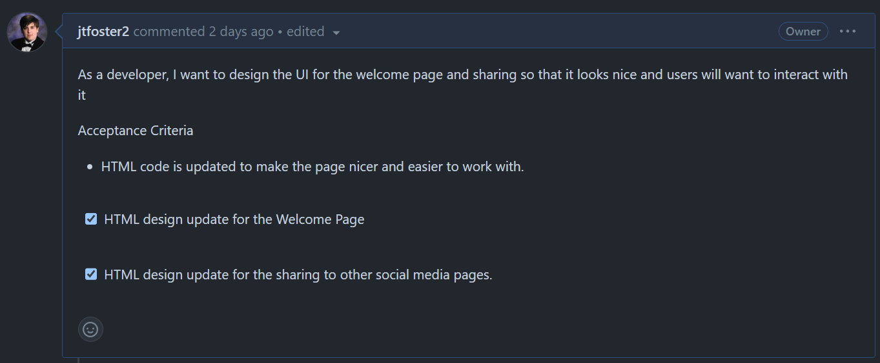

Sprint Burndown Chart: Implemented a Burndown Chart created by Joseph Hale: <https://github.com/thehale/github-projects-burndown-chart>

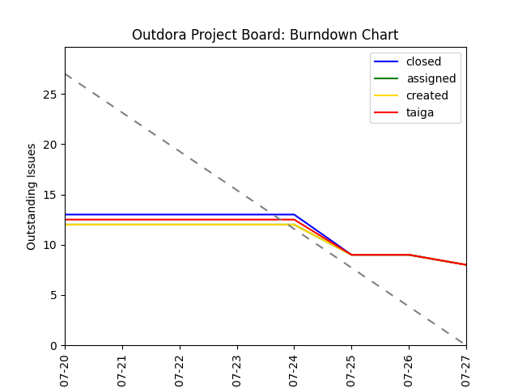

Pair Programming this Sprint: [ESEP - Team 2 - Silver Comets Standup-20240726_195125-Meeting Recording.mp4](https://kennesawedu-my.sharepoint.com/:v:/r/personal/jfost103_students_kennesaw_edu/Documents/Recordings/ESEP%20-%20Team%202%20-%20Silver%20Comets%20Standup-20240726_195125-Meeting%20Recording.mp4?csf=1&web=1&e=o0ah42&nav=eyJyZWZlcnJhbEluZm8iOnsicmVmZXJyYWxBcHAiOiJTdHJlYW1XZWJBcHAiLCJyZWZlcnJhbFZpZXciOiJTaGFyZURpYWxvZy1MaW5rIiwicmVmZXJyYWxBcHBQbGF0Zm9ybSI6IldlYiIsInJlZmVycmFsTW9kZSI6InZpZXcifX0%3D)

Sprint Review: [ESEP - Team 2 - Silver Comets Standup-20240728_191008-Meeting Recording.mp4](https://kennesawedu-my.sharepoint.com/:v:/r/personal/jfost103_students_kennesaw_edu/Documents/Recordings/ESEP%20-%20Team%202%20-%20Silver%20Comets%20Standup-20240728_191008-Meeting%20Recording.mp4?csf=1&web=1&e=LQHabd&nav=eyJyZWZlcnJhbEluZm8iOnsicmVmZXJyYWxBcHAiOiJTdHJlYW1XZWJBcHAiLCJyZWZlcnJhbFZpZXciOiJTaGFyZURpYWxvZy1MaW5rIiwicmVmZXJyYWxBcHBQbGF0Zm9ybSI6IldlYiIsInJlZmVycmFsTW9kZSI6InZpZXcifX0%3D)

Release: Project is currently built into a docker image that can be run locally on localhost:8080, as an artifact in individual action runs: <https://github.com/jtfoster2/Outdora/actions>